My Farmer Story

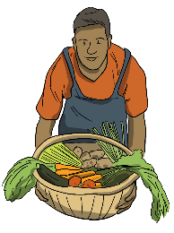 | 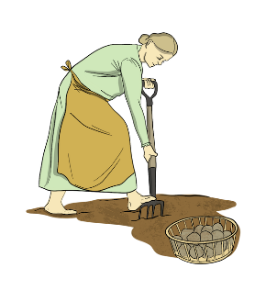 | 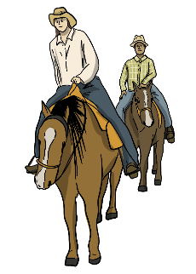 | 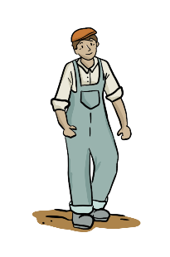 | 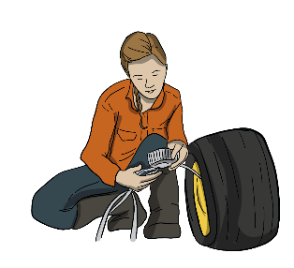

Imagine you are a farmer. Write a story about your life.
Include the following information.
- What year is it?
- Where is your farm?
- What is on your farm?
- Who eats the food you grow?
- How old are you?
- How many family members do you have?
- What do you do in the summer?
- What do you do in the winter?
- What technology do you use on your farm?
Do research on the website to help you learn what life for different farmers was like in the Past and what is like today.
Reference two pages on the website that you researched.
Example: Past – Farming – Farming Challenges

