PAST – FARMING - ANIMALS
Write a short story about these animals from the perspective of an early Settler.
Use 3 facts from the website on the PAST – FARMING – ANIMALS page.

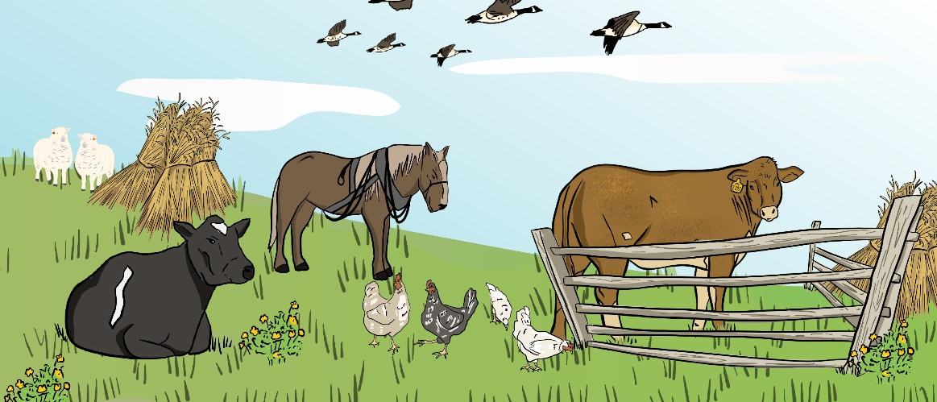

Name:________________________________ Date:_______________________________
Title:_______________________________________________________________________________

________________________________________________________________________________________________________________________________________________________________________________________________________________________________________________________________________________________________________________________________________________________________________________________________________________________________________________________________________________________________________________________________________________________________________________________________________________________________________________________________________________________________________________________________________________________________________________________________________________________________________________________________________________________________________________________________________________________________________________________________________________________________________________________________________________________________________________________
Use the back of this paper if you need more space.

