PAST – FARMING - BUILDING A HOMESTEAD
Write a short story about this picture.
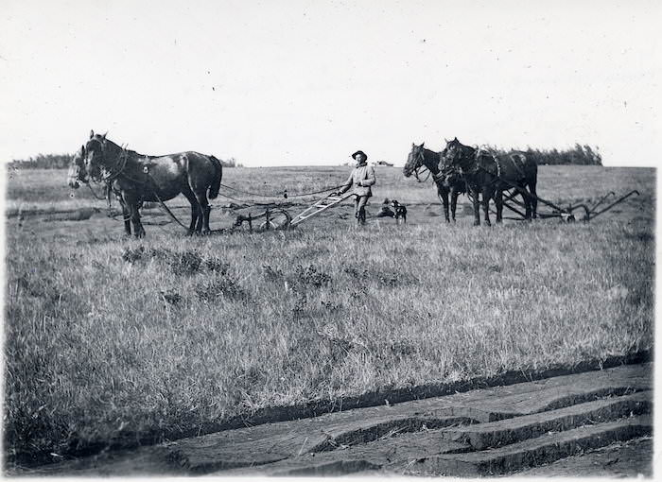
Use 3 facts from the website on the PAST – FARMING - BUILDING A HOMESTEAD page.

Name:________________________________ Date:_______________________________
Title:_______________________________________________________________________________
_______________________________________________________________________________________________________________________________________________________________________________________________________________________________________________________________________________________________________________________________________________________________________________________________________________________________________________________________________________________________________________________________________________________________________________________________________________________________________________________________________________________________________________________________________________________________________________________________________________________________________________________________________________________________________________________________________________________________________________________________________________________________________________________________________________________________________________________
Use the back of this paper if you need more space.

