PAST – FARMING - CROPS
Write a short story about the characters in this picture.
Use 3 facts from the website on the PAST – FARMING - CROPS page.
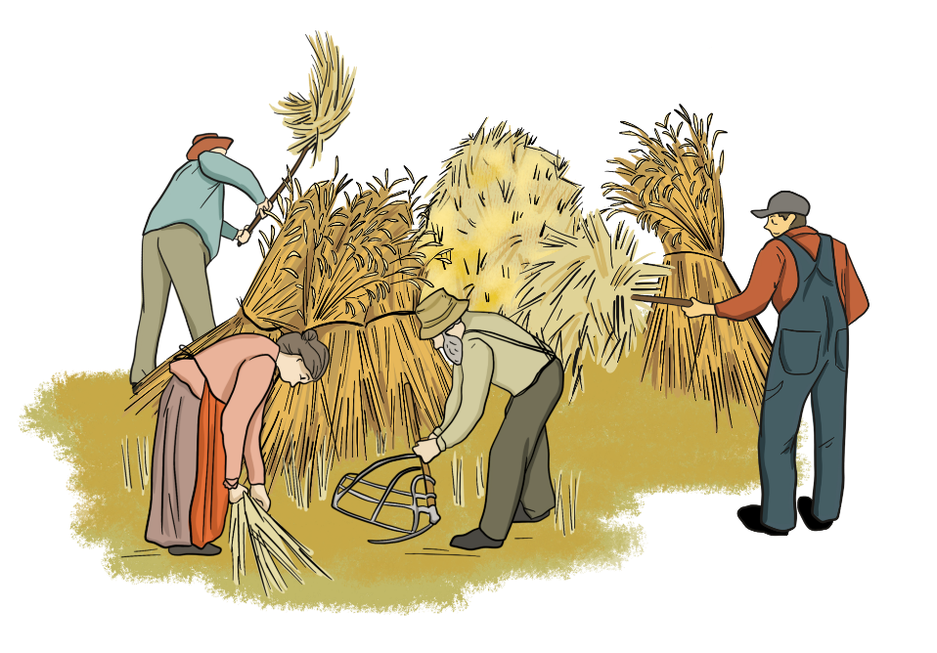

Name:________________________________ Date:_______________________________
Title:_______________________________________________________________________________

______________________________________________________________________________________________________________________________________________________________________________________________________________________________________________________________________________________________________________________________________________________________________________________________________________________________________________________________________________________________________________________________________________________________________________________________________________________________________________________________________________________________________________________________________________________________________________________________________________________________________________________________________________________________________________________________________________________________________________________________________________________________
Use the back of this paper if you need more space.

