PAST – FARMING - FARM EQUIPMENT
Write a short story about this picture.
Use 3 facts from the website on the PAST – FARMING - FARM EQUIPMENT page.
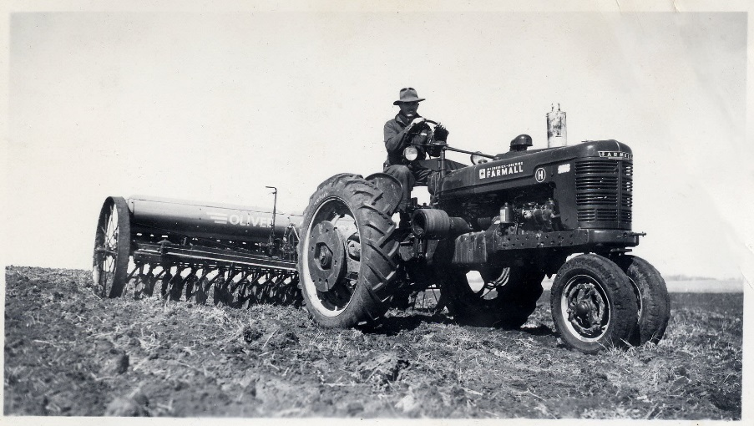

Name:________________________________ Date:_______________________________
Title:_______________________________________________________________________________

________________________________________________________________________________________________________________________________________________________________________________________________________________________________________________________________________________________________________________________________________________________________________________________________________________________________________________________________________________________________________________________________________________________________________________________________________________________________________________________________________________________________________________________________________________________________________________________________________________________________________________________________________________________________________________________________________________________________________________________________________________________________________________________________________________________________________________________
Use the back of this paper if you need more space.

