PAST – FARMING - FARM TOOLS
Write a short story about the people in this picture.
Use 3 facts from the website PAST – FARMING - FARM TOOLS page.
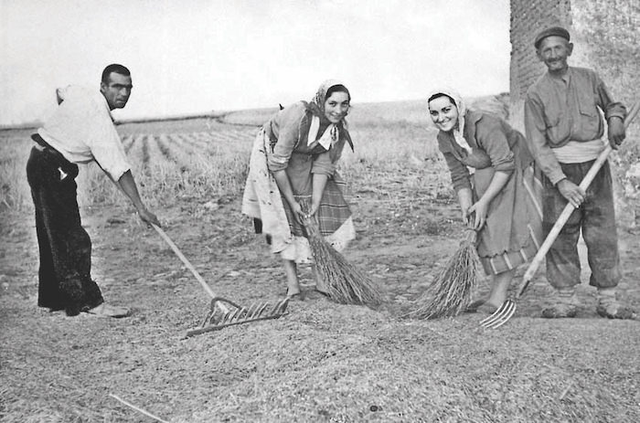

Name:________________________________ Date:_______________________________
Title:_______________________________________________________________________________

________________________________________________________________________________________________________________________________________________________________________________________________________________________________________________________________________________________________________________________________________________________________________________________________________________________________________________________________________________________________________________________________________________________________________________________________________________________________________________________________________________________________________________________________________________________________________________________________________________________________________________________________________________________________________________________________________________________________________________________________________________________________________________________________________________________________________________________
Use the back of this paper if you need more space.

