PAST – FARMING - FARMING CHALLENGES
Write a short story about this picture.
Use 3 facts from website PAST – FARMING - FARMING CHALLENGES page.
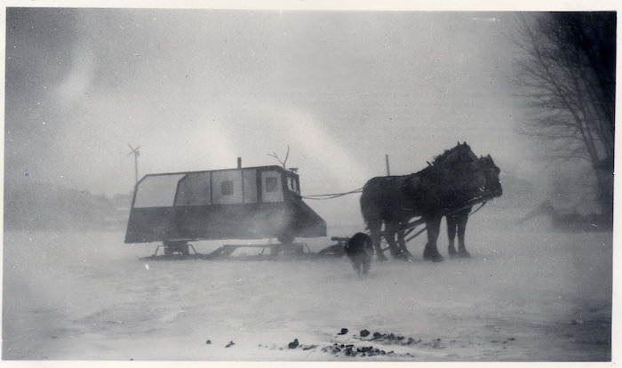

Name:________________________________ Date:_______________________________
Title:_______________________________________________________________________________

________________________________________________________________________________________________________________________________________________________________________________________________________________________________________________________________________________________________________________________________________________________________________________________________________________________________________________________________________________________________________________________________________________________________________________________________________________________________________________________________________________________________________________________________________________________________________________________________________________________________________________________________________________________________________________________________________________________________________________________________________________________________________________________________________________________________________________________
Use the back of this paper if you need more space.

