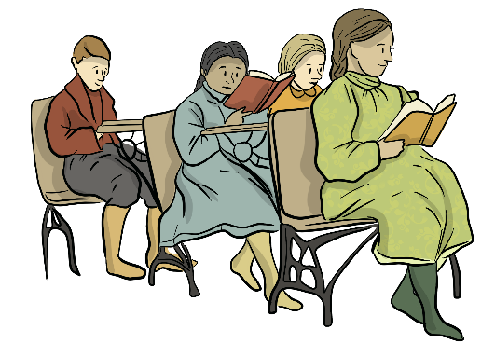
PAST – SETTLER LIFE – SCHOOLS
CREATING CONNECTIONS
Read the Past – Settler Life - Schools

- Text-to-self connection.
Reading about Settler schools reminds me of…
____________________________________________________________________________________________________________________________________
If I had to go to a school like this, I would…
____________________________________________________________________________________________________________________________________
When I read this, I felt… ____________________________________________________________________________________________________________________________________

- Text-to-text connections:

This reminds me of another book, story, movie because…
____________________________________________________________________________________________________________________________________

This is similar to other things I have read because…
___________________________________________________________________________________________________________________________________
This is different to other things I have read because:
____________________________________________________________________________________________________________________________________

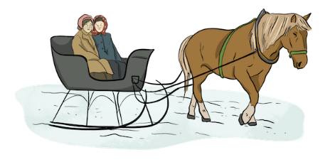
- Text-to-world connections:

I think schools are different today because …
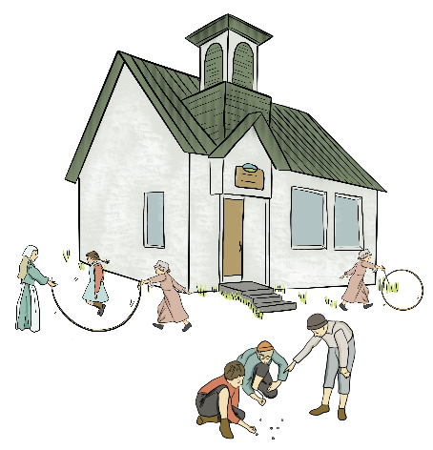
___________________________________________________________________________________________________________________________________What I just read in this section makes me wonder about…_________________________
_________________________________________
_________________________________________

