PAST – TRANSPORTATION
Name:________________________________ Date:_______________________________
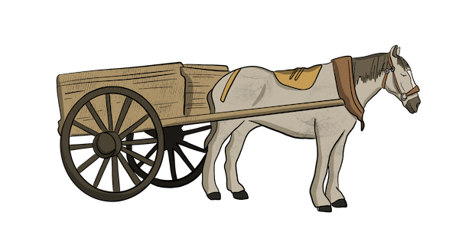 | 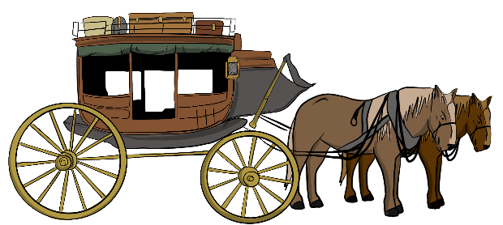
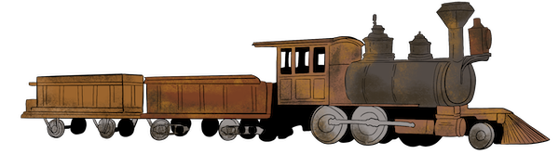 | 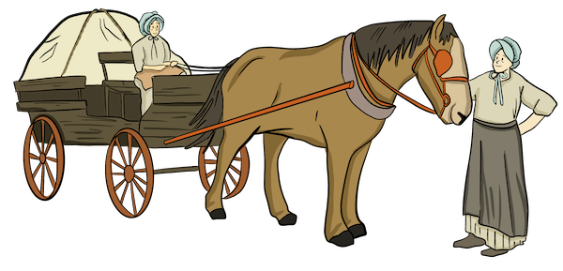
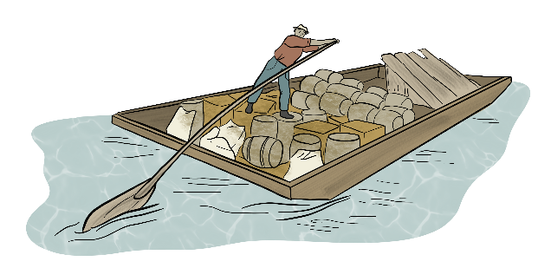 | 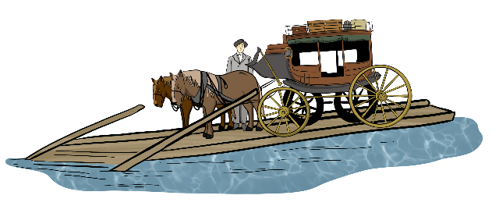
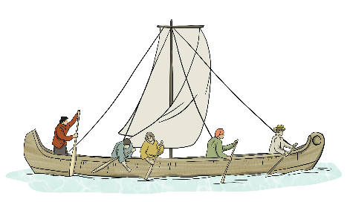 | 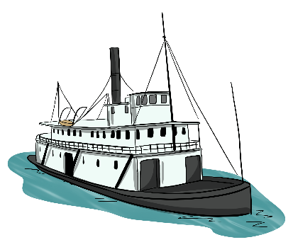
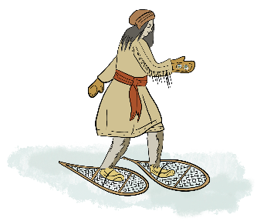 | 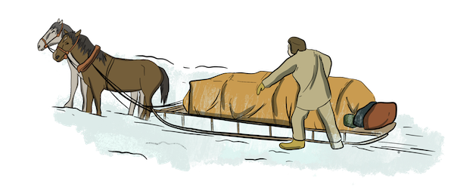
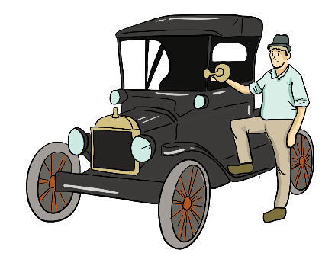 | 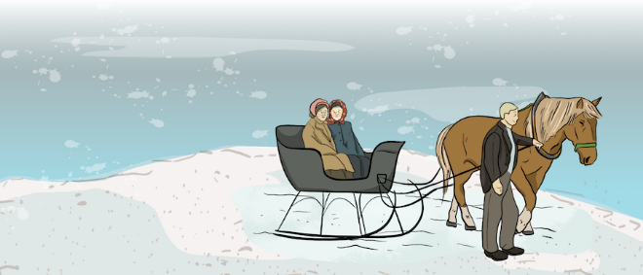

ACTIVITY:
- Pick two types of transportation from the images on page 1 that you want to learn more about. Circle them.

- Go to the Past – Transportation section and read about the different types of transportation you chose.

- Write two interesting facts about each.

Transportation Type 1:__________________________________

1.__________________________________________________________________________________________________________________________________________________________________________________
2.__________________________________________________________________________________________________________________________________________________________________________________
Transportation Type 2:__________________________________

1.__________________________________________________________________________________________________________________________________________________________________________________
2.__________________________________________________________________________________________________________________________________________________________________________________
Which one would you rather travel in and why?

