PRESENT – TYPES OF FARMS
Name:___________________________ Date:_______________________________
- Choose two of the following types of farms to learn about. Go to the Present – Types of Farms and read about two different types of farms. Write down one way the farmers take care of the land and/or animals.

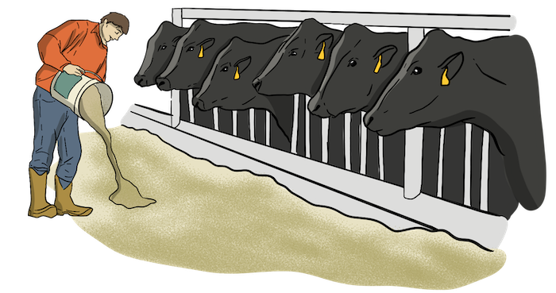
- Grain Farm
- Beef Farm
- Dairy Farm
- Poultry Farm
- Pork Farm
- Mixed Farm

Farm:__________________________________

_________________________________________________________________________________________________________________________________________________________________________
Farm:__________________________________

__________________________________________________________________________________________________________________________________________________________________________
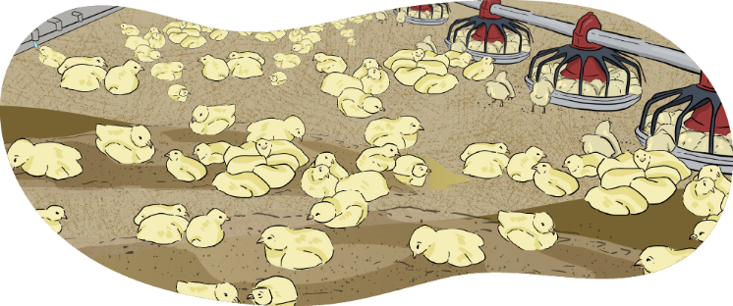
- Choose two of the following types of farms.
- Large Farm
- Small Farm
- Conventional Farm
- Organic Farm

- Give two examples of how they are similar?
____________________________________________________________________________________________________________________________________________________________________________________________________________________________________________________________________________________________________________________________________________________

- Give two examples of how they are different?
____________________________________________________________________________________________________________________________________________________________________________________________________________________________________________________________________________________________________________________________________________________

