Animals
- Which of these animals are farm animals? Circle the correct images below.

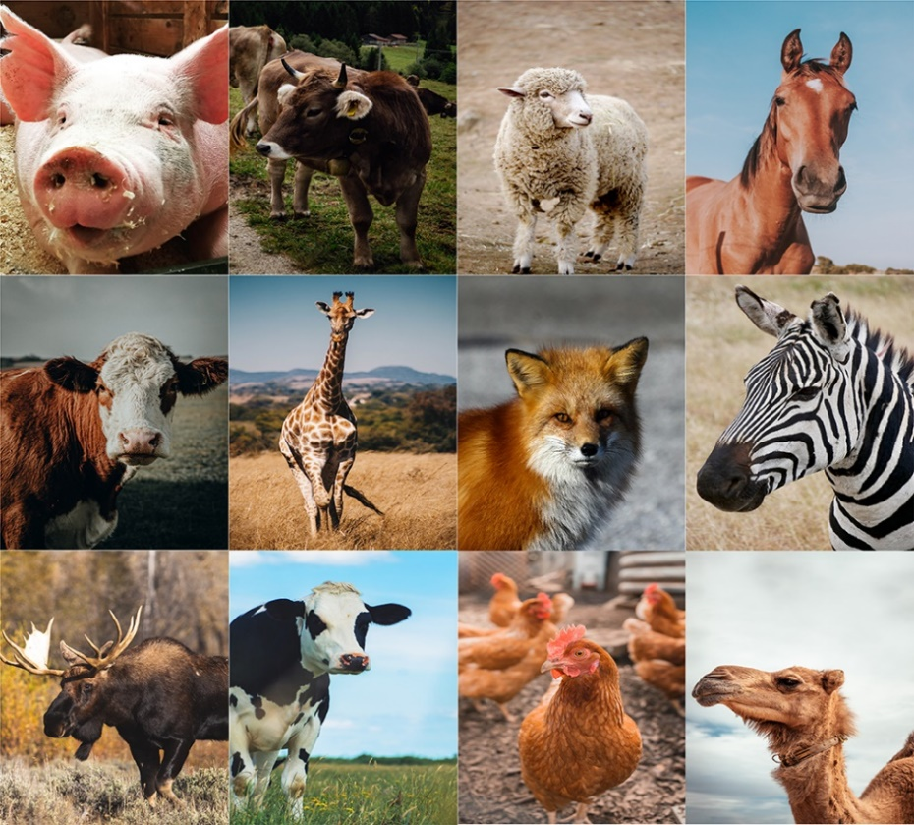

- Why were oxen used by early settler farmers?
  - They were stronger than horses
  - They were cheaper to buy
  - They could survive by eating prairie grass.
- Circle the items that chickens provided?
  - Meat
  - Feather
  - Water
  - Eggs

- Why was meat from pigs salted?
Meat from pigs was salted so it would last longer and not need to be kept cool.
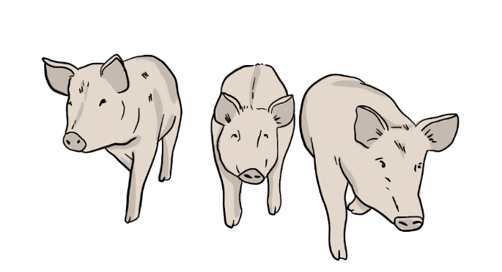
Building Homesteads
- What is the name for the gatherings that settlers had to help each other build their barns?
- Get togethers
- Parties
- Bees

- Before the steam engine arrived, settlers used teams of horses or oxen to remove trees and stumps from the ground.
- True
- False

- Why are barns red?
  - Farmers added rust to the linseed oil they sealed their barns with, and the rust turned the mixture red.
  - Farmers added red berries to oil then painted it on the barn to deter wolves and coyotes from coming to the barn.

- What was the easiest and cheapest way for settlers to make a home?
  - Building a log cabin
  - Building a sod house
  - Living in a fabric tent

- What are 2 types of homes that settlers built?
- Sod houses
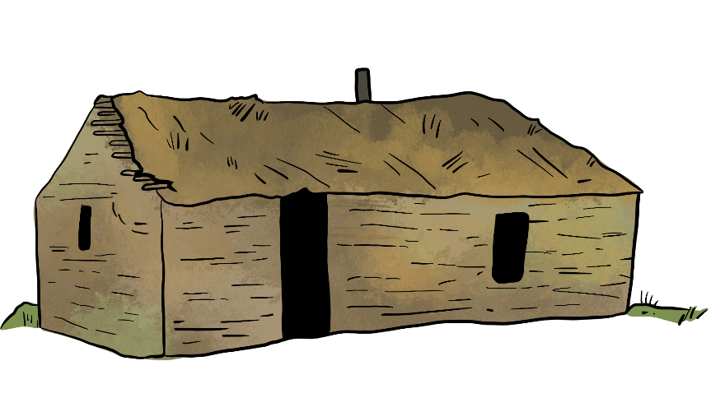
- Mansions
- Log houses
- Brick houses

Farming Challenges
- If grain prices were too low, farmers did not make any money.
- True
- False

- What are four reasons crops could fail?
- Too dry or too moist soil
- Weeds taking over
- To many farmers working the land
- Insects
- Extreme temperature
- People walking on the crop

- The Peasant Policy was put in place to keep First Nations farmers to only produce __________?
Answers:
- Corn
- Enough for their family
- Crops that needed machinery
- Vegetables

- First Nations farmers did not have the freedom to make their own decisions on what to buy and sell or the freedom to leave the reserve without permission from an Indian Agent.
Answers:
- True
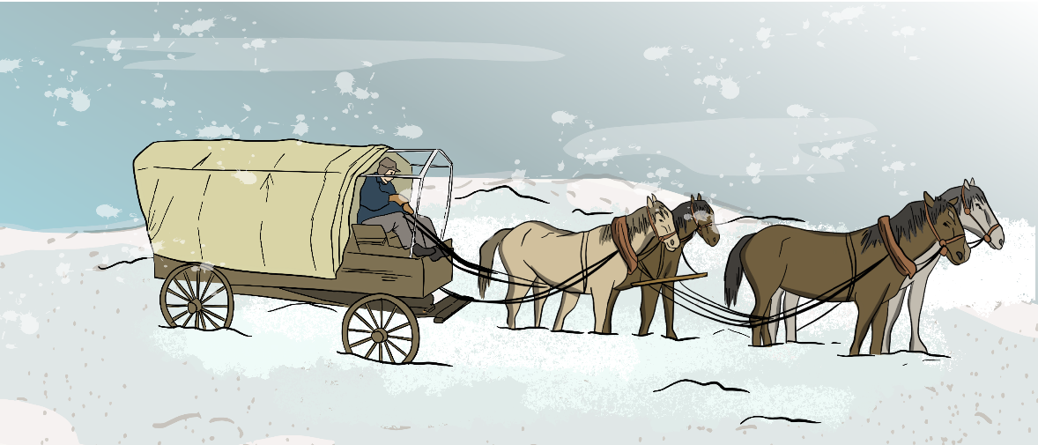
- False

Crops
- What type of farm work is being done when the grain seed is removed from the straw and husks?
- Threshing
- Planting
- Ploughing
- What type of farm work uses a team of horses to break up the soil so a crop could be planted?
- Plowing the land
- Feeding horses
- Harvesting
- During harvest and once cut, bunches of crop stalks were bunched together in ______ in order to dry.
- Stooks
- A Winnowing Tray
- A Barn
- During harvest, families and neighbours often worked together to get everything done in time before the first frost.
  - True
  - False
- Name 3 crops grown by the Early Settlers.
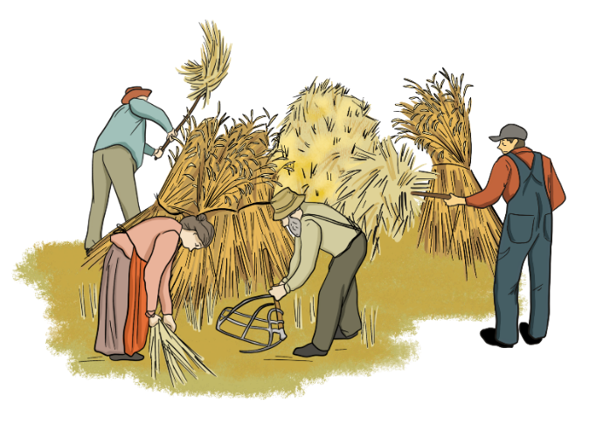
Options: Barley, wheat, rye, oats and/or flax.

Farm Equipment
- Why was the Steam Engine tractor not often used on a farm?
The Steam Engine was not commonly used because it was difficult to use for most farm tasks and because the engineers who knew how to operate the machine were difficult to find.
- How did the gasoline-powered tractor help farmers?
Gasoline-powered tractors reduced the amount of labour required to run a farm and allowed the farms to run more efficiently.

- In 1890, it took 40-50 hours to produce 100 bushels of wheat. By 2010, how long did it take to produce 100 bushels of wheat.

  - 5 hours
  - 5 minutes
  - Less than one hour

- Which piece of equipment looks like a large rake and is pulled over the soil to break up lumps and smooth out the land?

  - Cultivator
  - Harrow
  - Plow

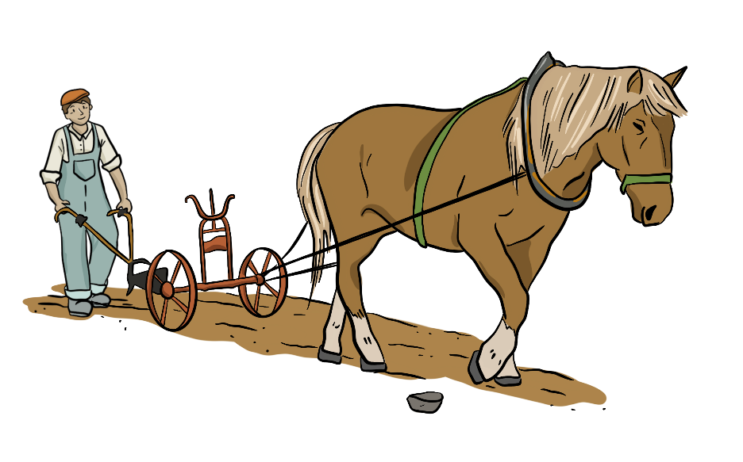
Farm Tools
Match the farm tool with one of the words from the word bank below.
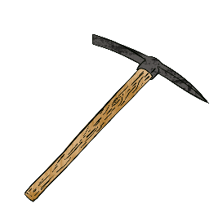 | PICK AXE | 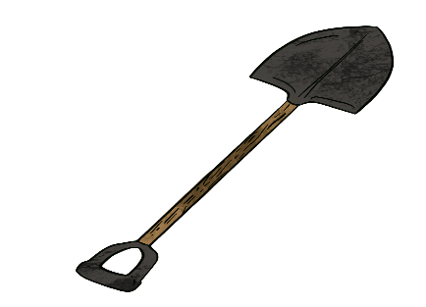 | SPADE
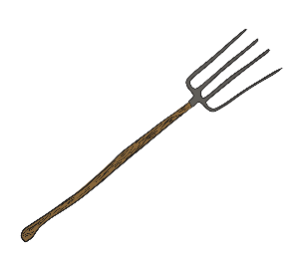 | PITCHFORK | 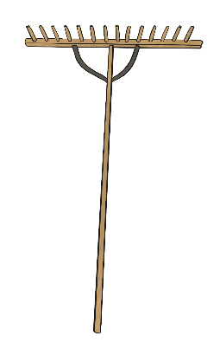 | WOODEN RAKE
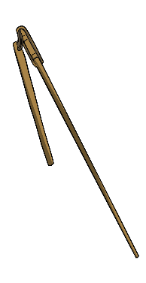 | FLAIL | 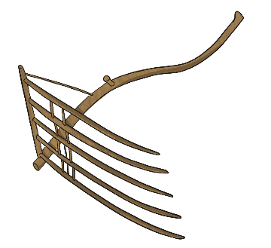 | CRADLE SCYTHE
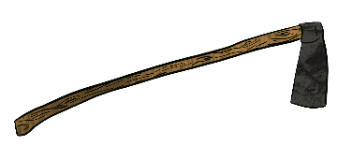 | HOE | 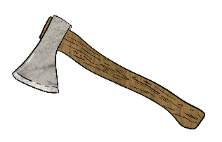 | AXE

WOODEN RAKE
PITCHFORK
SPADE
HOE
AXE
FLAIL
PICK AXE
CRADLE SCYTHE

